Annexure-B

YOGA CERTIFICATION BOARD
Ministry of AYUSH, Govt. of India
68, Ashoka Road, New Delhi-110001
Ph.23354634, 23354695, Telefax:23711657
e-mail: ceoycb18-mdniy@nic.in; Web: www.yogacertificationboard.nic.in

Applications are invited for engagement of Principal Consultant from eligible candidates on a maximum remuneration of Rs.1,50,000/- per month for Yoga Certification Board, Ministry of AYUSH, Government of India. The last date for receiving the applications is 19th June, 2020.
Sl | Name of the Post | No. of  Posts | Maximum Remuneration  (Rs.)per month | Work place
1. | Principal consultant | 01 | 150,000/-pm | YCB
Details of qualifications, experience, format of application and other terms & conditions of engagement for this post can be obtained from the website www.yogacertificationboard.nic.in, www.yogamdniy.nic.in and www.ayush.gov.in. Interested persons possessing the required qualifications, experience, etc. may send their applications in prescribed format by speed post or via email to ceoycb18-mdniy@nic.in with the subject “Application for the post of Principal Consultant, Yoga Certification Board, Ministry of AYUSH, Govt. of India”. The short-listed candidates will be called for an interview at Yoga Certification Board, details of which will be conveyed in due course of time. Applications received after the closing date or without the prescribed documents or otherwise found incomplete in the prescribed proforma are liable to be rejected and no correspondence shall be entertained in this regard. CEO

No. 1-38/YCB/Pr Const/A&F/2020
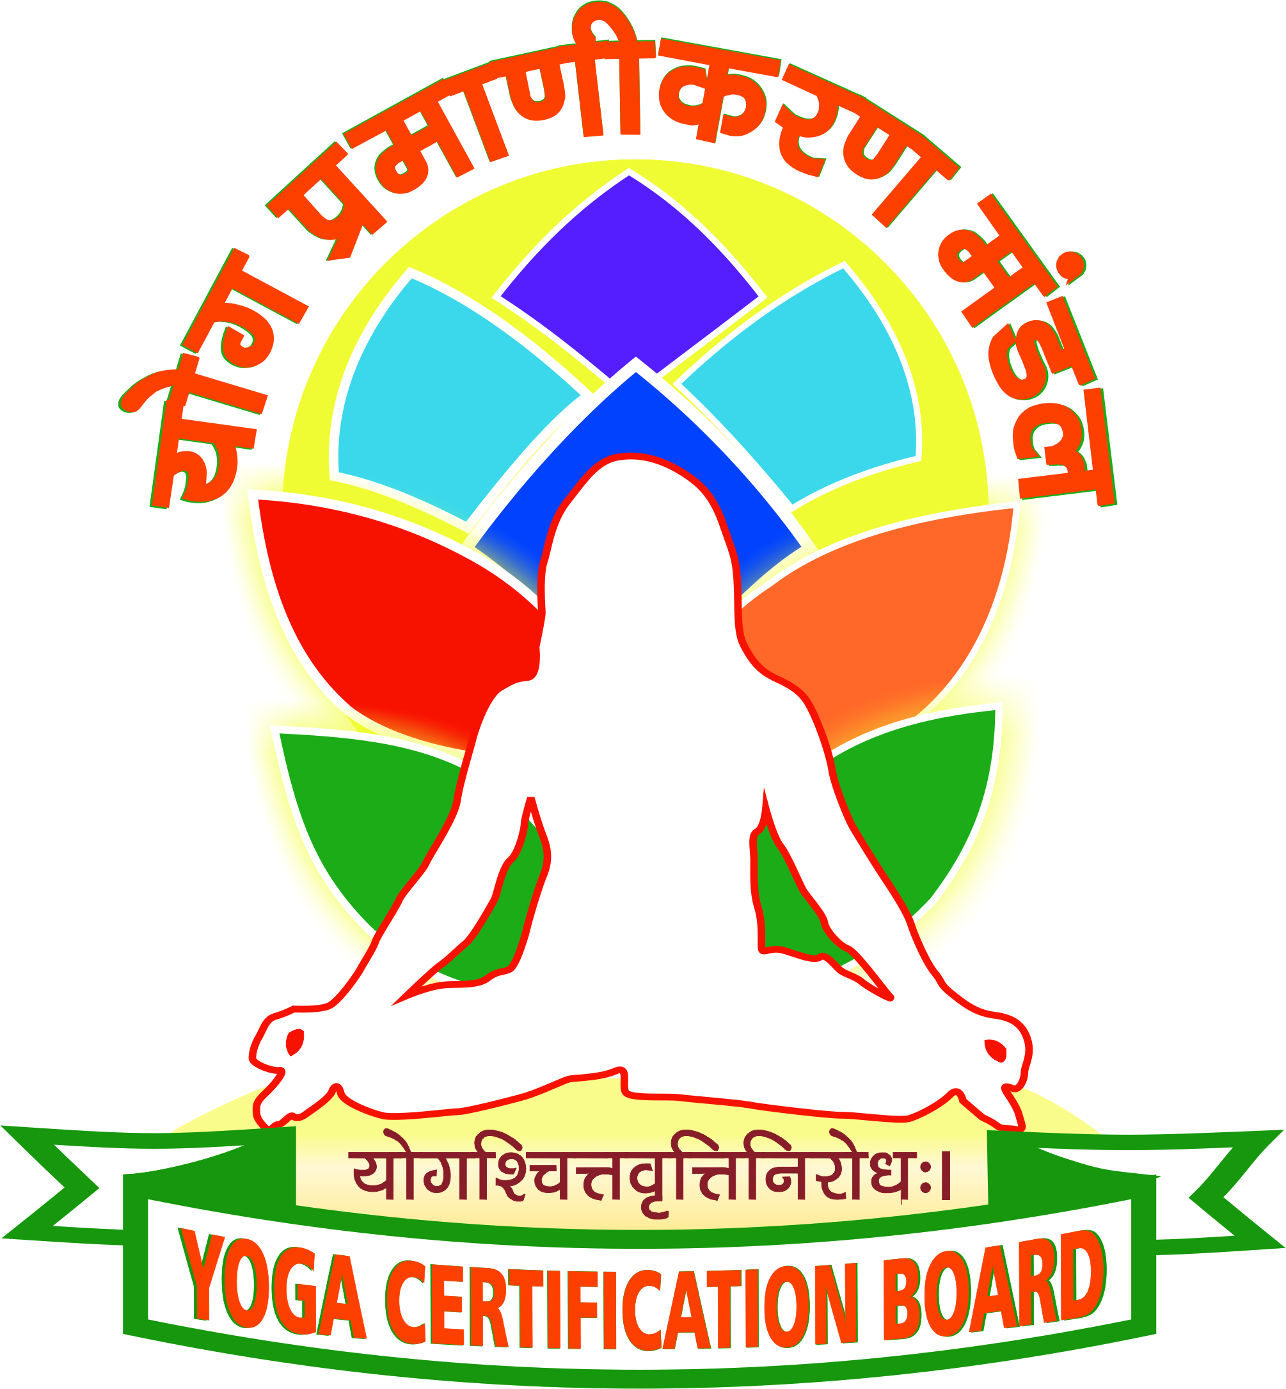
YOGA CERTIFICATION BOARD
Ministry of AYUSH,
Government of India

68, Ashok Road, New Delhi,
13th May, 2020

Advertisement for Principal Consultant in Yoga Certification Board, Ministry of AYUSH, Government of India

Applications in the prescribed proforma (as per Annexure- I to the advertisement) are invited from eligible candidates for engagement of 01 (One) Principal Consultant in Yoga Certification Board, Ministry of AYUSH, Government of India, New Delhi, as per details given below:

1 | Name of the Post | : | Principal Consultant in Yoga Certification Board
2 | Period of Consultancy | : | - One year, or till the post of Chief Executive Officer is created and an incumbent is posted against it, whichever is earlier.
3 | Nature of Duties | : | The Selected consultants will be required to perform the following duties:  - Responsible for Management and administration of Yoga Certification Board including supervision and control over day to day administration, finance, IT, technical issues, legal and Public Relations.  - Responsible to conduct the business of the Board and various committees entrusted with Policy Formulation, Course Content, Evaluation Criteria for Certification & Accreditation  - Organise, plan and execute various program for Certification of Yoga Professionals and Accreditation for improving professionalism in the Yoga Sector  - Continuous Monitoring and Evaluation of Yoga Certification and Accreditation processes  - Coordination with various stakeholders and consensus building  - Maximizing the use of IT in the functioning of the Board
4 | Job Location | : | • Yoga Certification Board, MDNIY  68, Ashok Road, New Delhi-110001 or any such location/s as identified by the Board/Ministry.
5 | Qualifications/Experience | : | Essential  (i) Holding post graduate qualification;  (ii) At least 10 years of administrative experience at the equivalent level of Deputy Secretary and above in Government of India, Statutory bodies, Public Sector Undertakings, Autonomous Bodies, Universities or in any other institutions (including teaching faculties), recognized by Government of India/ State Government and  (iii) Experience of working in computerized environment with proficiency in MS office and database management software etc,  Age Criteria:  Persons not exceeding 64 years of age on the date of publication of the advertisement with qualifications as detailed above.
6 | Desirable | : | (i) M.Phil/ Ph. D preferably in Yoga (Knowledge of Yoga practice) or Administration/ Management; and  (ii) Having experience to set up or heading a certification organization.
7 | Remuneration | : | The maximum remuneration will be Rs. 1.50 Lakhs per month subject to restrictions in accordance with Pension Rules, or other government rules, if applicable.
8 | How to apply | : | - Interested applicants may submit application indicating their interest in working for the Yoga Certification Board as per proforma at Annexure- I.  - The applications in the prescribed format should be sent via email or by speed-post to ceoycb18-mdniy@nic.in with the subject “Application for the post of Principal Consultant in the Yoga Certification Board, Ministry of AYUSH, Government of India”.  - References from past employers may be included.  - The applications should include the contact details of the candidate, including residential address, email ID and land line and mobile numbers.  - The duly signed application as per Annexure-I (with colour photograph pasted thereon) and supporting documents should be scanned and converted to the PDF format before sending them by email.  - Yoga Certification Board will review the applications and will shortlist candidates it considers suitable.  - The short-listed candidates will be called for an interview in Yoga Certification Board, details of which will be conveyed in due course.  - The candidates shortlisted for interview will be required to bring along application and supporting documents, in original, on the day of interview.  - Candidates will have to make their own arrangements to reach the place of interview.  - No TA/DA will be payable by the Board/Ministry to attend the interview.  - The decision of the Board/ Government on selection of candidates will be final.

The last date for receiving applications is 19th June, 2020. Applications received after the closing date or without the prescribed documents or otherwise found incomplete or not in the prescribed proforma are liable to be rejected and no correspondence shall be entertained in this regard.

*****

ANNEXURE-I

APPLICATION PROFORMA FOR THE POST OF PRINCIPAL CONSULTANT IN YOGA CERTIFICATION BOARD, MINISTRY OF AYUSH, GOVERNMENT OF INDIA
Paste your passport size photo here

- Name :

- Date of Birth :

- Gender :

- Educational Qualifications :

- Mobile No :

- Email ID :

- Details of employment in chronological order, if applicable. (Enclose a separate sheet, if space below is insufficient)
Department/ Institution/ Organisation | Post held | From | To | Emoluments | Nature of duties performed

- Details of courses/training programmes attended, if any :

- Languages known :

- Details of previous Consultancy, if any

- Recommendations :

- Additional information, if any, which you would like to mention in support of your suitability for the post. Enclose a separate sheet, if need be.

- Remarks, if any :

(Signature of candidate)
Address :

Date :

